Securely Communicating Over an IPv6 Network
User Manual

Zeina Abdel Samad
School of Applied Technology
Illinois Institute of Technology
201 East Loop Road
Wheaton, IL 60189
(312) 833-4701
zabdelsa@hawk.iit.edu

Olivia Minton
School of Applied Technology
Illinois Institute of Technology
201 East Loop Road
Wheaton, IL 60189
(773) 747-0613
jcallana@hawk.iit.edu

Bartlomiej Dworak
School of Applied Technology
Illinois Institute of Technology
201 East Loop Road
Wheaton, IL 60189
(708) 299-1171
bdworak@hawk.iit.edu

Douglas Wilhelm
School of Applied Technology
Illinois Institute of Technology
201 East Loop Road
Wheaton, IL 60189
(269) 588-0595
dwilhel1@hawk.iit.edu

ABSTRACT
In our paper we look at the implementation of secure network communication utilizing the IPv6 Internet protocol. The Internet has been around since the early 1980s, and in that time has been operating on a protocol referred to as Internet Protocol version 4, often shortened to IPv4. While this protocol is the foundation of the Internet, it has many vulnerabilities and security flaws, and its address space is too limited for continued use. A newer version of the protocol was released, IPv6, which expands on the original IPv4 implementation and other security features. In this project we create a network operating purely on the IPv6 protocol and communicating securely between hosts using IPsec authentication and encryption.

Categories and Subject Descriptors
C.2.2 [Network Protocols]:
Protocol architecture (OSI model), Protocol Verification
General Terms
Experimentation and Security.
Keywords
IPv6, Ubuntu, IPsec, Networking, Servers, Security.

CONFIGURATION
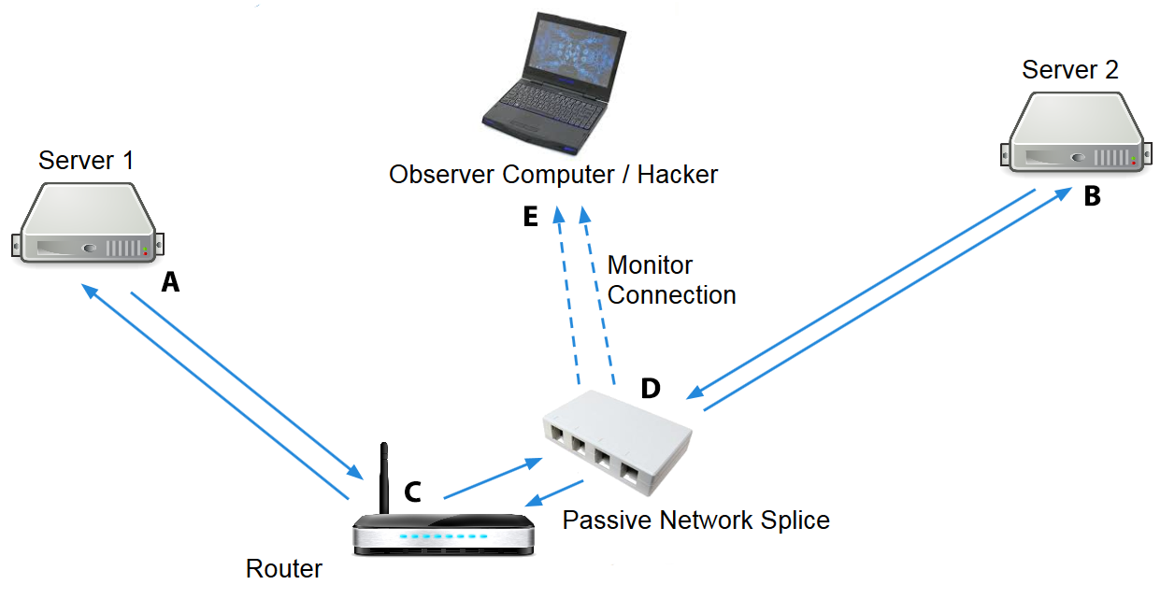
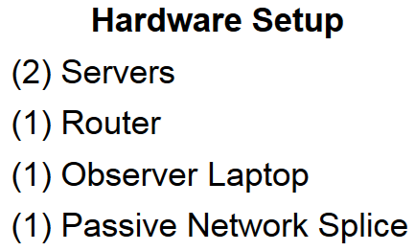
Figure 1. Local Network Configuration

The IPv6 protocol stack had to be configured on both the host machines along with the router.
Two of our hosts were configured using static IPv6 addresses. Before we were able to use our systems and enable the network interfaces we had to find the names of the interfaces assigned by the system. This can be done by running the following command: sudo lshw -class network. This command identified our network interfaces on the hosts which both turned out to be p4p1.
On an Ubuntu system the location of the network configuration file is found at /etc/network/interfaces. This file is edited to configure the network interfaces. The network interfaces on both hosts were configured using static IPv6 addresses. This is achieved by using the following configuration line: iface p4p1 inet6 static. Following this line was the configuration for each host that had its own static IPv6 address.
Once both hosts were configured with static IPv6 addresses a ping test was run to check for connectivity between the hosts. The hosts were able to successfully ping each other.

Router Configuration

Navigate to the default IPv4 address for the router.

192.168.1.1

Log in with the default credentials:

Username: admin

Password: admin

Under the setup tab, navigate to the Network sub-category. Change the IP setting from IPv4 Only to Dual-Stack IP.

Also under the setup tab, navigate to the IPv6 Transition tab. Disable the 6to4 tunnel, since this feature will not be needed.

Under the DHCP tab, navigate to the DHCP Setup sub- category. In the IPv4 tab that shows up, disable all settings. Under the IPv6 tab, enable IPv6 DHCP Server.

Server Ubuntu Installation
- Download the latest Ubuntu Server release onto a flash drive
- Install the operating system using the default settings on three (3) server rack units
- Set up the primary user account as follows:

Username: controller

Password: letmein

Server Configuration
- Identify network Ethernet interfaces. Run the following command:
sudo lshw -class network
- Gather the appropriate logical network interface name; ours on each server was:
p4p1
- Edit the network interface file for each server. Run the following command:
sudo vi /etc/network/interfaces
- Ensure that each configuration file contains the following lines of code. This file assigns the unique IPv6 network address to each of our interfaces as well as a dhcp IPv4 address for us to be able to download software from the internet and remote into the host via SSH. The interface used for ipv6 testing is a separate NIC and does not interface with the IPv4 network therefore all communication happening on the IPv6 network are only seen on the IPv6 network and no other network garbage is transmitted on the link.
    - auto lo
    - iface inet lo loopback
    - iface p4p1 inet6 static
    - address fc00::62a4:4cff:4cff:fe24:4eea - 1st Server
    - address fc00::62a4:4cff:4cff:fe24:4eeb - 2nd Server
    - address fc00::62a4:4cff:4cff:fe24:4eec - 3rd Server
    - netmask 64
    - gateway fc00::1
    - auto p5p1
    - iface p5p1 inet dhcp
- Restart networking with the following command:
/etc/init.d/networking restart
- Verify the IPv6 address assign with the following commands:
ifconfig p4p1
ip -6 address show p4p1
- Test a ping between the two systems:
ping6 (IPv6 Address)

Securing connectivity on an IPv6 network
The two test hosts have been configured to communicate solely using the IPv6 protocol however this did not provide much security for the communications between the two hosts.
A solution was found to set up IPsec for communication between the hosts. Both hosts were configured with a tool called ipsec-tools. This tool can be installed on Ubuntu by running the following command: sudo apt-get install ipsec-tools.
This tool creates a configuration file that can be found at /etc/ipsec-tools.conf. This file is read by the tool and alters the communication packets if the conditions are met. The configuration file consists of three sections, AH, ESP and Security Policy.
In the first section the Authentication Header (AH) keys are set for both hosts to allow the hosts to verify the packets are coming from the actual host rather than a man in the middle. In the next section the Encapsulating Security Payload is configured which allows for both hosts to encrypt the payload inside of the IPv6 packet.
Finally the security policy is configured which adds route information to the hosts so that if communication between the secured hosts is encrypted using IPsec. Once our ipsec-tools were configured we brought the server online using the following command: sudo /etc/init.d/setkey start. A ping test confirmed that both hosts were online and communicating.

IPsec Configuration
  - Ensure that each server is connected to the internet through each respective spare Ethernet interface (p5p1)
  - Run the following command to install the proper application packages:
sudo apt-get install ipsec-tools
  - Modify the IPsec configuration with the following command:
sudo vi /etc/ipsec-tools.conf
  - Modify the IPsec configuration so that the outside world may not edit the file with the following command:
sudo chmod 750 ipsec-tools.conf
  - Begin the IPsec service with the following command:
sudo /etc/init.d/setkey start

TESTING

Testing the Security of the IPsec Communications
To test our IPsec setup we had to be able to monitor traffic on the wire between the two hosts. The router we had acquired for the testing did not have functionality to create a monitoring port to view the packets traveling between the hosts. Our team ended up creating a network tap device similar to the type a real hacker would use to monitor network traffic anonymously on a network. An enclosure and four network sockets were found.
The wiretap allows for a network interface card running in promiscuous mode to monitor the traffic on the network, and since the TX ports are not hooked up to the monitor ports, the host cannot accidentally taint the network with its own communications.
Our network tap had two monitoring ports, one looking at TX and one looking at Rx. This is done by creating a network port with only the Orange and White-Orange wires attached, and the other having the Green and White-Green wires attached. Using this monitoring box our team was able to attach one of the hosts to the monitoring box and monitor the communications on the wire. The ping test mentioned in the previous section was run once again and a Wireshark trace confirmed that both hosts were communicating using IPsec ESP in each IPv6 packet payload.

Testing Procedures
    - Network Splice Tool:
- Gather the following resources:
Punch down network tool, 1ft Cat 5E Ethernet wire, four (4) RJ45 female IDC connector jacks, scissors, and RJ45 4-port containment module
- Using the scissors, cut an appropriate length of Cat 5E wire, and remove the twisted pairs of inner wires from the cable housing. Untwist the pairs of wire until you have individual strands of wire, which will be different colors.
- Wire the jacks together in accordance with the following diagram. Use the punch down network tool to cut off the excess wire when the wires are placed into the correct wire slots on the female IDC RJ45 jacks.
- Place the jacks inside of the RJ45 4-port containment module, and assemble the module to be a complete boxed unit. Label the top of the box according to each port’s purpose.
    - Testing the secure connection with ping:
- Run the following command to test the security of ping packets:
ping6 (IPv6 Address)
    - Testing the secure connection with HTTP:
- Run the following command to test the security of HTTP packets:
curl “http://[(IPv6 Address)]”
Note: the square brackets must be used to denote that the address is an IPv6 address
    - Testing the secure connection with SSH:
- Run the following command to test the security of SSH packets:
ssh -6 controller@(IPv6 Address)

Testing the Security of IPsec Communications
To test our IPsec setup we had to be able to monitor traffic on the wire between the two hosts. The router we had acquired for the testing did not have functionality to create a monitoring port to view the packets traveling between the hosts. Our team ended up creating a network tap device similar to the type a real hacker would use to monitor network traffic anonymously on a network. An enclosure and four network sockets were found.
The wiretap allows for a network interface card running in promiscuous mode to monitor the traffic on the network, and since the TX ports are not hooked up to the monitor ports, the host cannot accidentally taint the network with its own communications.
Our network tap had two monitoring ports, one looking at TX and one looking at Rx. This is done by creating a network port with only the Orange and White-Orange wires attached, and the other having the Green and White-Green wires attached. Using this monitoring box our team was able to attach one of the hosts to the monitoring box and monitor the communications on the wire.
Using three common types of packets (ping, HTTP and SSH) demonstrates the security of our network. The test mentioned in the previous section was run once again and a Wireshark trace confirmed that both hosts were communicating using IPsec ESP in each IPv6 packet payload. If the packets had not been encrypted, they would not appear in the traces as ESP, but rather, as their respective services.

BIBLIOGRAPHY
- Curl. (2014). Manual Curl Usage Explained. Retrieved from Curl: http://curl.haxx.se/docs/manual.html
- Karunaratne, J. (2014). Passive Splice Network Tap. Retrieved from Janitha: http://janitha.com/articles/passive-splice-network-tap/
- nixCraft. (2014). Cyberciti. Retrieved from Ipv6 Apache Configuration Tutorial: http://www.cyberciti.biz/faq/ipv6-apache-configuration-tutorial/
- nixCraft. (2014). Ubuntu Ipv6 Networking Configuration. Retrieved from Cyberciti: http://www.cyberciti.biz/faq/ubuntu-ipv6-networking-configuration/
- Ubuntu. (2014). IPsecHowTo. Retrieved from Ubuntu: https://help.ubuntu.com/community/IPsecHowTo
- Ubuntu. (2014). Ubuntu Network Configuration. Retrieved from Ubuntu: https://help.ubuntu.com/10.04/serverguide/network-configuration.html

